**B2-SET B**

**PART A**

1. Predict the output of the following

from pyDatalog import pyDatalog

pyDatalog.create_terms("X,Y")

print((X==(1,2)+(3,)) & (Y==X[2]))

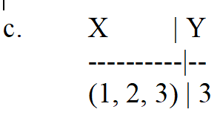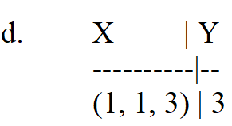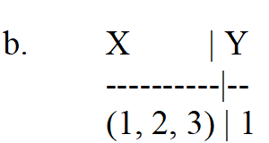

a. X | Y

----------|--

(1, 2, 3) | 2

**Ans : C**

1. Identify the correct syntax from the following
2. pydatalog.create_terms('X,Y')
3. pyDatalog.create_term('X,Y')
4. pyDatalog.create_terms('X','Y')
5. **pyDatalog.create_terms('X,Y')**
6. Bind() needs for binding with socket
7. **IP Address and Port number**
8. IP version and Port number
9. Socket family and port number
10. Socket type and port number
11. A push down automaton employs ________ data structure.

a) Queue

**b) Stack**

c) Hash Table

d) Linked List

5. STREAM and DGRAM is purely meant for

a. UDP and TCP

b**. TCP and UDP**

c. FTP and TCP

d. UDP and HTTP

6. What is a python library that can be used to send and receive data over HTTP?

a) http **b) urllib** c) port d) header

1. Find the output of the following

import sympy as sym

sym.simplify((x + x * y) / x)

a. X+2

b. X+1

c. Y+2

**d. Y+1**

8. Find the correct syntax for the expression 2cos(2x)

a. sym.diff(sym.tan(2 * x), x)

b. sym.diff(sym.cos(2 * x), x)

**c. sym.diff(sym.sin(2 * x), x)**

d. sym.diff(sym.limit(2 * x), x)

1. Predict the output of the follwoing

from sympy import *

rslt = oo + 10000

print("value of rslt is :" + str(rslt))

a. value of rslt is :1000

b. value of rslt is :1001

c. value of rslt is :NULL

**d. value of rslt is :oo**

1. The set of all strings over the alphabet S = {a, b} (including e) is denoted by
2. **(a + b)\***
3. (a + b)+
4. a+b+
5. a*b*